`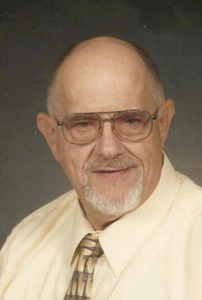 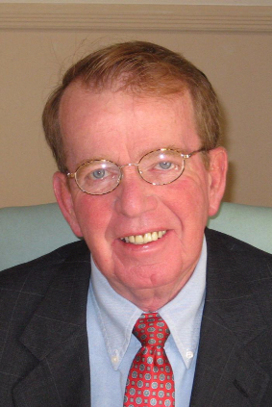 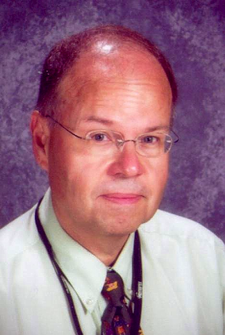 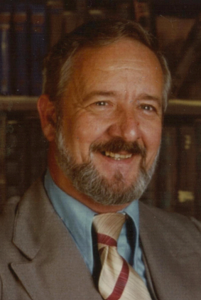

**COLIN V. SINGER JOHN P. CAVISTON C. WILLIAM PETRICS EVERETT C. ERTLE**

**Founding Dist. Deputy 1990-1992 1992-1993 1993-1994**

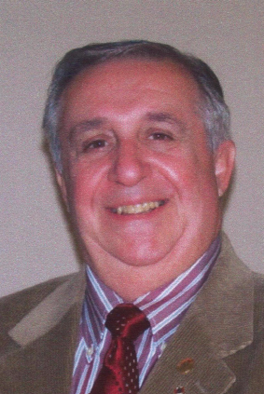 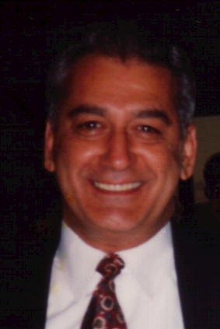 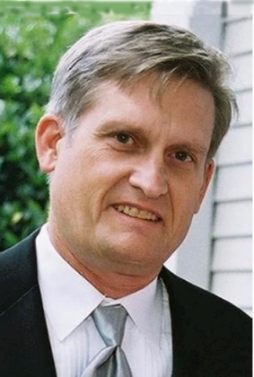 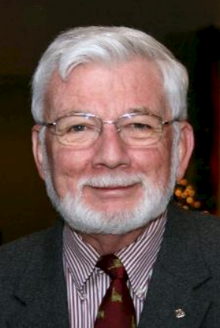

**JOHN J. BATTISTA PETER D’AGOSTINO PAUL HAGGERTY ROBERT ALMQUIST**

**1994-1995 1995-1996 1996-1997 1997-1998**

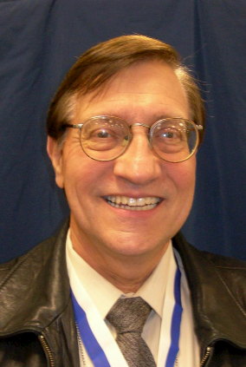 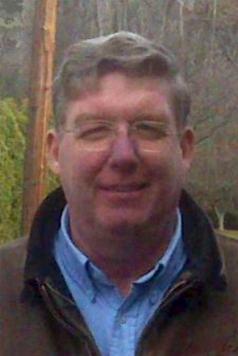  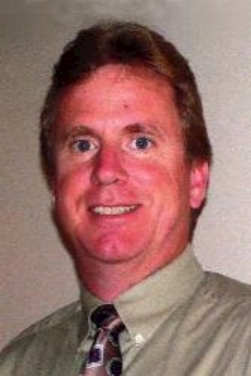

**ART CATALUSCI STEPHEN T. SHANLEY STUART M. PALMER BRIAN E. LEE**

**1998-1999 1999-2000 2000-2001 2001-2002**

**PAST GRAND KNIGHTS-LONG VALLEY COUNCIL 10419**